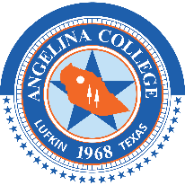

ANGELINA COLLEGE
BOARD OF TRUSTEES
Board Committee Agendas
October 18, 2022
5:45 p.m.

- Call to Order

- Student Affairs & Athletics
  - Discussion of Athletics leadership transition
  - Presentation of Diversity & Inclusion Annual Calendar
  - Discussion of serving students in poverty and the working poor
  - Tour of newly created student lounge and “nonquiet” study space
  - Discussion of student retention & graduation initiatives – moving the needle on outcomes

- Adjourn

